**Alekhya Krishna Balivada SQL Day 7 Assessment-7(11-12-2023)**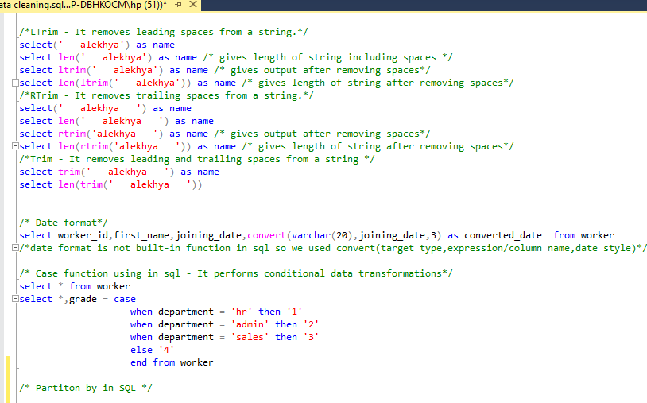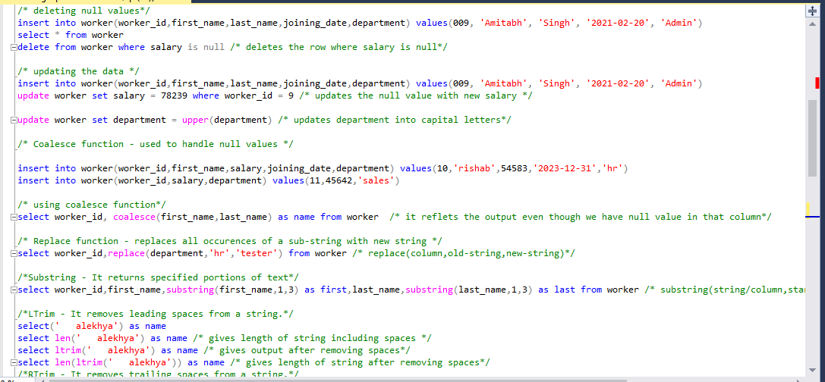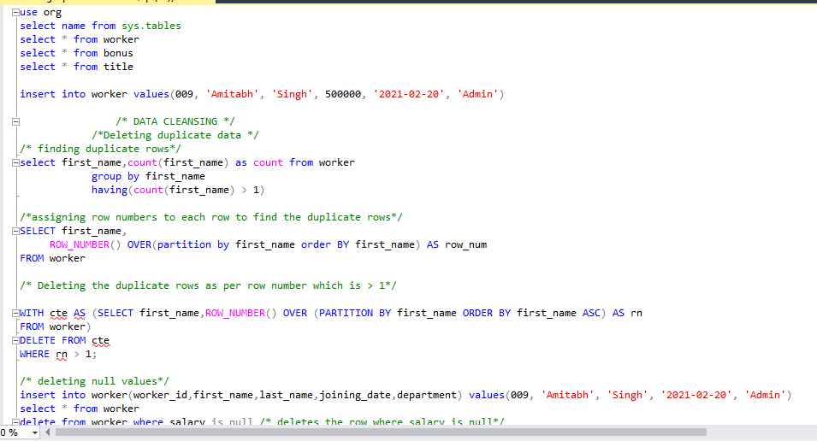

**Deleting duplicate data**

1. Updating the data
2. Coalesce function
3. Replace function
4. Substring
5. Ltrim

1. Rtrim
2. Trim function
3. Date format
4. Case function

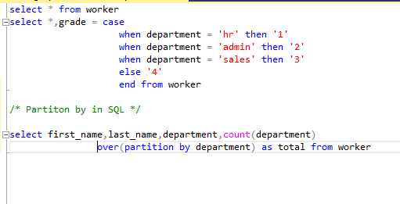

**Using Partition by function**



**Database diagrams in SQL**